***Experiment 2 Output***

Data preprocessing using python machine learning libraries.

**Original Dataset:**

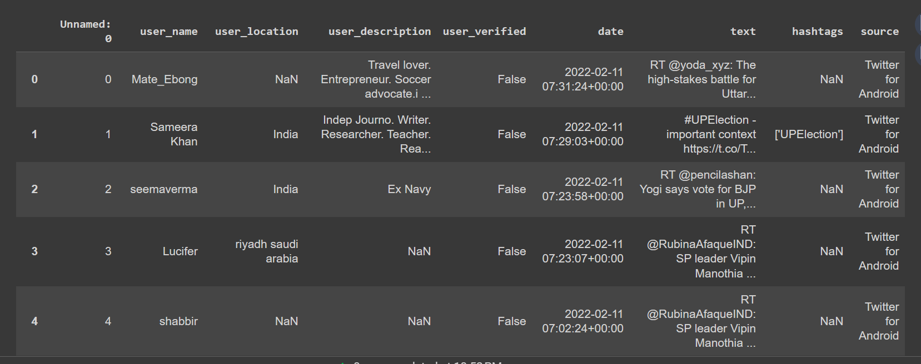

**Null Value Count:**

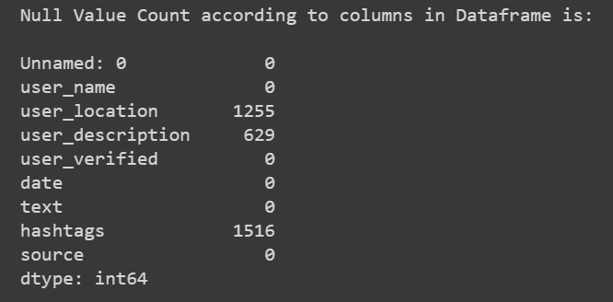

**Preprocessed Dataset:**

